Questions and Exercises to work out and turn in:

Grading Guidelines:

A right answer will get full credit when:

1. It is right (worth 25%)
2. It is right **AND** neatly presented making it easy and pleasant to read. (worth an **extra** 15%)
3. There is an **obvious and clear link[1]** between 1) the information provided in the exercise and in class and 2) the final answer. A clear link is built by properly writing, justifying, and documenting an answer (worth an **extra** 60%).
4. Calculation mistakes will be minimally penalized (2 to 5% of full credit) while errors on units will be more heavily penalized.

**Late Submission** : as specified in the syllabus. Days counting starts one minute after the deadline.

**Check Your Submission:**  after submitting, download your submission to check whether it is the right version and it is complete.

You are welcome/encouraged to discuss exercises with other students or the instructor. But, ultimately, **personal** writing is expected.

* USE THIS FILE AS THE STARTING DOCUMENT YOU WILL TURN IN. **KEEP IN THE QUESTIONS** AND INSERT YOUR ANSWERS.
* IF USING HAND WRITING (STRONGLY DISCOURAGED), REWRITE THE QUESTIONS.
* FAILING TO FOLLOW TURN IN DIRECTIONS /GUIDELINES WILL COST A 30% PENALTY.

Objectives of this assignment:

* to compute the "Internet Checksum" on a stream of bits
* to evaluate the impact of the distance on the throughput and efficiency of stop-and-wait protocol.

What you need to do:

Answer the questions and/or solve the exercises described below.

Logical Link Layer

Exercise 1 (35 points)

#### Suppose that a message 1110 1011 1100 1100 (w1 w2 w3 w4) is transmitted using Internet Checksum (4-bit word). The objective is to compute the checksum. In order to determine the checksum follow steps

#### An n-bit Internet Checksum is computed as follows:

#### 1) Break the stream of bits in n-bit words w1, w2, ..., and wm. For the message 1110 1011 1100 1100, list the words w1, w2, ..., and wm.

2) Compute the n-bit word S = w1 + w2, if there is a carry then set S = S + 1. Execute this step on Message 1110 1011 1100 1100.

3) Compute S = S + w3, if there is a carry then set S = S + 1, Execute this step on Message 1110 1011 1100 1100.

........

n) Compute S = S + wn, if there is a carry then set S = S + 1. Execute this step on Message 1110 1011 1100 1100.

Finally, the Internet Checksum = ~S (one-complement of S)

Exercise 2 (65 points)

#### **The objective of this exercise is to realize how high distance and high bandwidth affect the performance of stop and wait.**

#### The distance from Earth to a distant planet is approximately 9 x 109 km. Assume that the frame size is 10 Kbits and the speed of light is 3 108 m/s. Assume that the bit rate is 4 Mbps.

1. (10 points) What is the efficiency (channel utilization) if a stop-and-wait protocol is used?
2. (20 points) Suppose we use a window protocol. What should be the window size in frames to achieve the maximal efficiency (channel utilization)?
3. (17.5 points) Plot the efficiency versus the distance when the bit rate is set to 4 Mbps. The x-axis will have distances from 0km to 9 x 1010 km. I recommend you to use a graphing tool (e.g., Excel). Discuss this plot. We are interested in the impact of distance over the efficiency. **Avoid hand-made plots.**
4. (17.5 points) Plot the efficiency versus the bit rate when distance is set to 9 x 109 km. The x-axis will have bit rates from 0 bit/s to 5 Gbps. I recommend you to use a graphing tool (e.g., Excel). Discuss this plot. We are interested in the impact of bitrate over the efficiency. **Avoid hand-made plots.**

**What you need to turn in**:

* Electronic copy of this file (including your answers) (standalone). Submit the file as a Microsoft Word or PDF file.
* Recall that answers must be well written, documented, justified, and presented to get full credit.
* How this assignment will be graded:
* A right answer will get full credit when:
* It is right (worth 25%)
* It is right AND neatly presented making it easy and pleasant to read. (worth 15%)
* There is an obvious and clear link between 1) the information provided in the exercise and in class and 2) the final answer. A clear link is built by properly writing, justifying, and documenting an answer (worth 60%).
* Calculation mistakes will be minimally penalized (2 to 5% of full credit) while errors on units will be more heavily penalized.
* You are welcome/encouraged to discuss exercises with other students or the instructor. But, ultimately, personal writing is expected.

**Appendix**: Grading: What is an OBVIOUS and CLEAR LINK?

Here is an example to explain what an **obvious and clear link** is and how we grade your work.

Consider the following problem:

"(100 points) John travels from Auburn to Atlanta in his car at a speed of 60 mph. Leaving at 8am, at what time will John reach Atlanta".

Here are the answers of three students and their scores:

* **Student 1** answers: "9:48am". Student 1 will get 25 points.
* **Student 2**answers : "John will reach Atlanta at 9:48am". Student 2 will get 25+15 = 40 points
* **Student 3** answers: "The time t to travel a distance d at speed v is equal to d/v = d/60mph. The problem does not provide the distance d from Auburn to Atlanta. Based on GoogleMaps, the distance from Auburn to Atlanta is approximately 108 miles (**document is attached**).

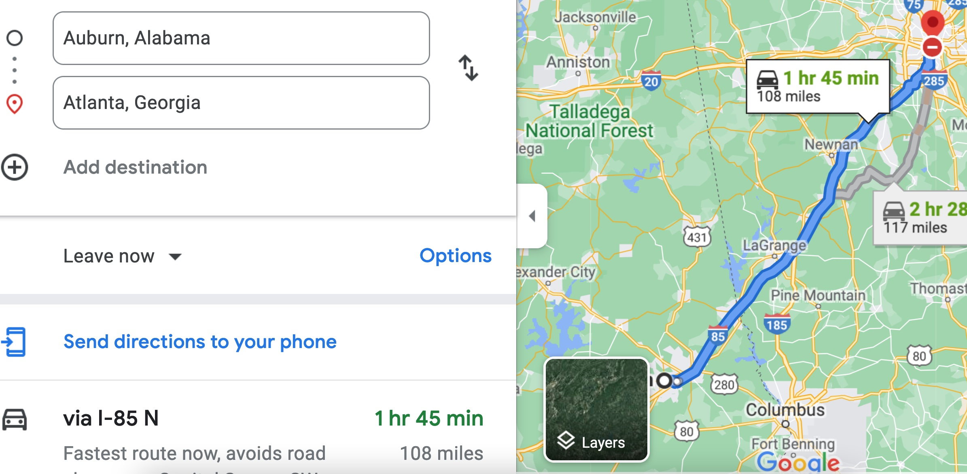

Therefore, the time t = 108 miles/60mph * 60 minutes/hour= 108 minutes. Since John left at 8am, he will then reach Atlanta at 8am + 108 minutes = 8 am + 60 minutes + 48 minutes = 9:48".

**Student 3** will get 25 + 15 + 60 = 100 points

Do you see the **direct** **link** going from the data provided in the question to the final answer, using general knowledge/formula and documents?.... Can you now solve the following problem and get 100 points?

"(100 points) Alice travels from Auburn to Atlanta in her car at a speed of 60 mph. Leaving at 8am, at what time will Alice reach Atlanta assuming that she had a flat tire that delayed her 30 minutes".

1. Check the appendix about what an obvious and clear link is.